Maker Space Witney – What might it look like?
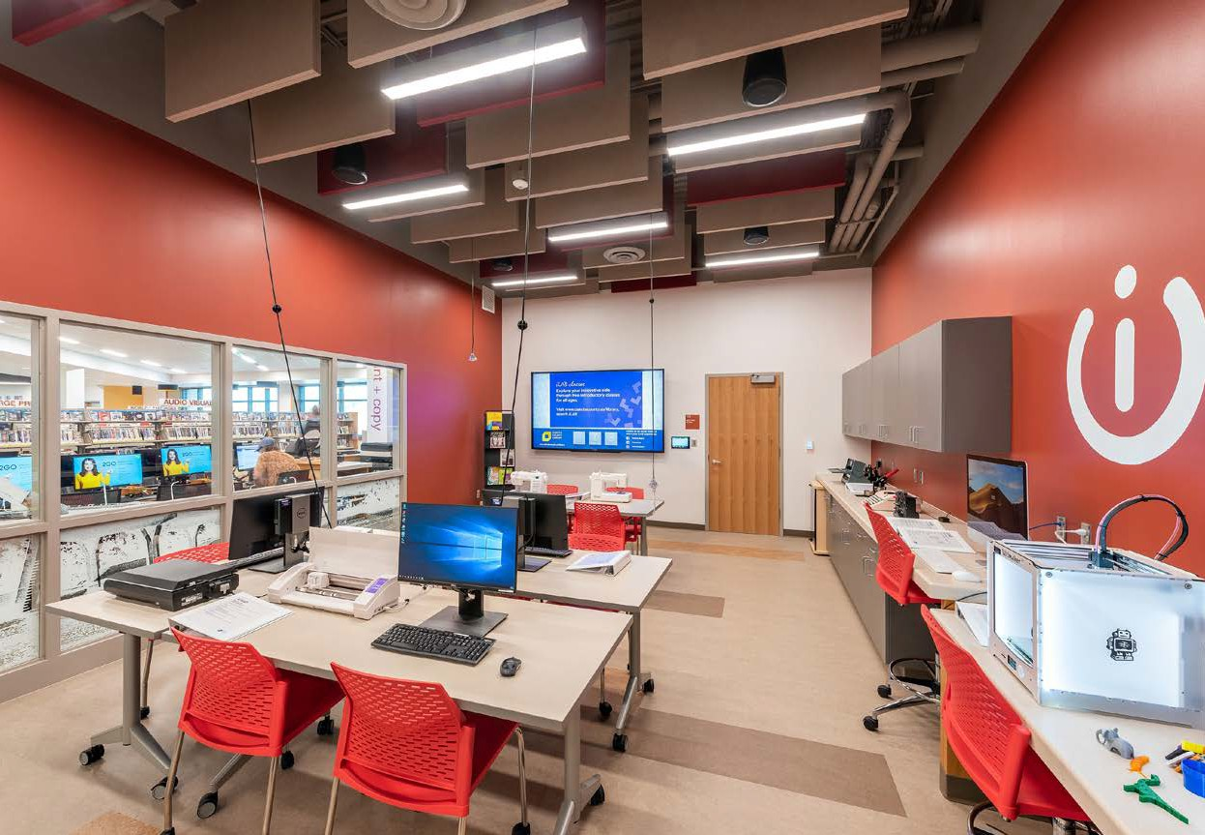
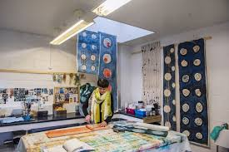
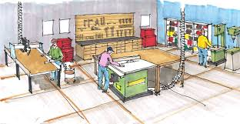
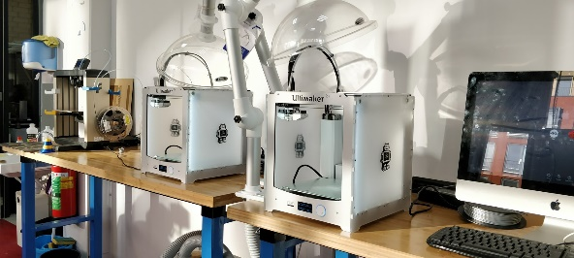
1
2
3
15
6
4
13
14
5
12
11
7
8
10
9
Configuration dependant on space and final selection of activities.
Textiles
[Cite your source here.]
Woodworking

Tech Area
[Cite your source here.]

T

Woo
3D Printing
[Cite your source here.]

